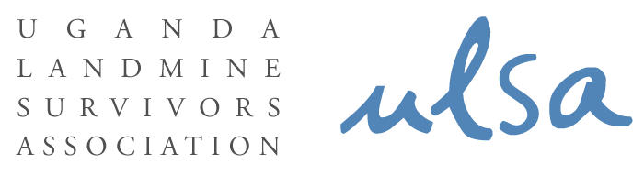

CLUSTER MUNITIONS CONVENTION
PRESS RELEASE

The Cluster Munitions Convention is a legally binding International Treaty that obliges States Parties to end the use, production, and transfer of cluster munitions.
It calls for immediate destroying of stockpiled cluster munitions within eight years of joining the convention, clearing land contaminated by cluster munitions within 10 years and requires the state to provide victim assistance to those affected by these weapons.

The Cluster Munitions Convention was negotiated in May 2008, opened for signature in December 2008, and became binding International Law on 1 August 2010. To date, 108 countries have signed this convention, 43 have ratified it and 10 have already enacted National Legislation to implement the Convention.

On 3 December 2008, Uganda became a signatory to the Convention. The State Minister for Foreign Affairs Hon. Okello Oryem signed the convention in Oslo, Norway in the presence of a Ugandan contigent comprising of Members of Parliament, Civil Society and Religious Leaders.

According to the new Cluster Munition Monitor that was released on 1 November, 2010, in Bangkok, the Cluster Munitions Convention is effective in saving civilian lives.
The Monitor estimates that prior to the start of the global effort to ban cluster munitions, 86 countries stockpiled millions of cluster munitions containing more than one billion submunitions. Currently, 74 countries have stockpiles.

The Monitor also reveals that as of the end of 2009, 16,816 cluster munition casualties had been recorded in at least 27 states and three areas. Due to under-reporting, the actual number of cluster munition casualties might be as high as 85,000 worldwide.
The majority of victims lack comprehensive assistance, particularly economic inclusion and psychosocial support.

On 9 – 12 November, 2010, Uganda will join other states parties, for the 1st Meeting of States Parties in Laos PDR. This meeting will lay the foundation for future engagement on the convention by bringing together for the first time States Parties to the convention, UN agencies, international organizations, civil society and cluster bomb survivors.

Which way Uganda? Will you Ratify the Convention on Cluster Munitions?

