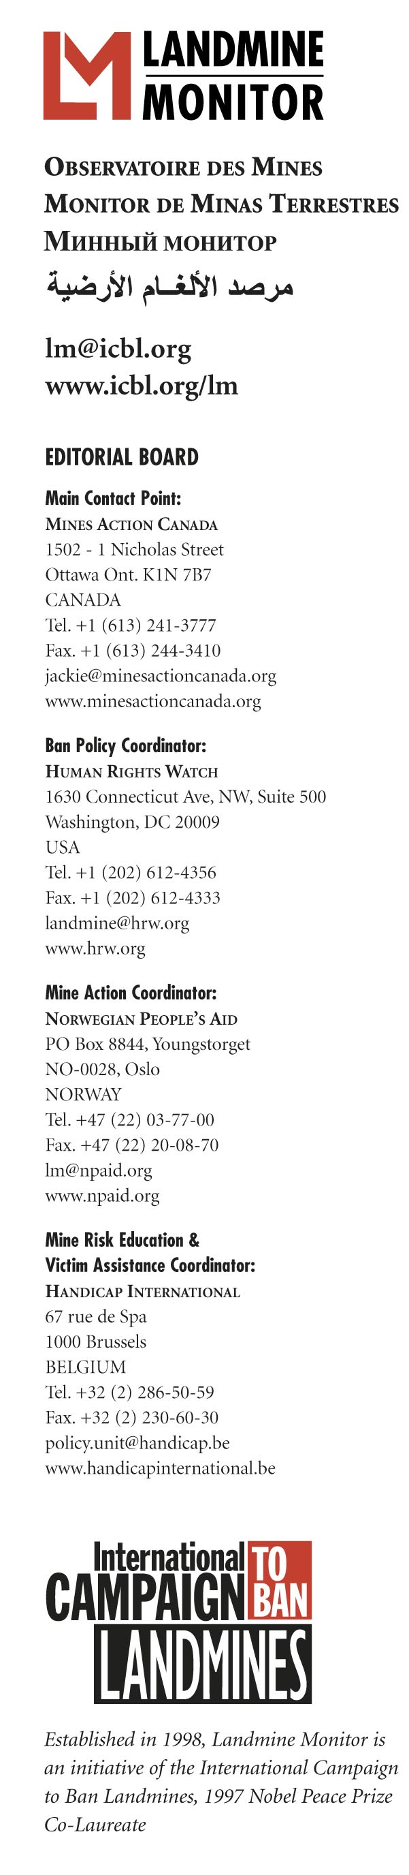
EMBARGOED UNTIL 10:30 GMT, 21 NOVEMBER 2008

1997 MINE BAN TREATY SUFFERS FIRST SERIOUS VIOLATIONS according to Landmine Monitor Report 2008 released today

GENEVA, Switzerland – 21 November 2008 – Three countries have failed to meet deadlines to destroy landmine stockpiles putting them in violation of the Mine Ban Treaty and 15 others have requested more time in order meet their mine clearance obligations under the Mine Ban Treaty, according to Landmine Monitor Report 2008: Toward a Mine-Free World. This 1,155 page report is being released today at the United Nations.

Greece and Turkey, with a combined stockpile of 4.2 million antipersonnel mines, are in serious violation of the treaty after failing to meet their 1 March 2008 deadline to complete the destruction of stocks. Belarus also missed its 1 March destruction deadline with 3.4 million antipersonnel mines remaining to destroy. However, Belarus is working to secure funding to destroy its stocks of PFM-type mines, which are difficult and costly to destroy, and completed destruction of all its non-PFM-type mines at the end of 2006.

“This is the first major violation of this treaty obligation,” said Steve Goose of Human Rights Watch, Landmine Monitor’s Ban Policy Editor. “However, the Mine Ban Treaty has led to the destruction of nearly 42 million stockpiled mines, removing the threat these weapons could pose to civilians.” Since the publication of the previous Landmine Monitor report, Afghanistan, Burundi and Sudan have completed stockpile destruction, and 500,000 mines were destroyed.

Keeping States Parties on track to clear all mined areas is the greatest challenge the treaty has faced. Approximately two-thirds of States Parties with 2009 clearance deadlines—15 states—have declared they will not meet them and have requested deadline extensions.

“It is reasonable that severely mine-affected countries, despite extensive work to rid their countries of mines, will require additional time to complete the work,” said Stuart Casey-Maslen of Norwegian People’s Aid, Landmine Monitor’s Mine Action Editor. “However, it is not acceptable that countries such as the United Kingdom and Venezuela, both with relatively little mine contamination, have failed to clear a single mined area in the last nine years and expect to be granted extensions to their mine clearance deadlines.”

Since May 2007 France, Malawi and Swaziland have declared completion of mine clearance operations, bringing the total number of affected States Parties that have fulfilled their treaty obligations to clear all antipersonnel mines from mined areas under their jurisdiction or control to 10. However, more than 70 states and six areas not internationally recognized remain mine-affected. Mine contamination was reported in the Gambia and Mali for the first time in 2007.

“A small group of countries is failing to meet some of their Mine Ban Treaty obligations,” said Jacqueline Hansen, Landmine Monitor’s Project Manager. “However, they are the exception. Support for the treaty continues to grow, sending a strong signal that the treaty has helped to stigmatize mine use worldwide.”

New government use of antipersonnel mines was recorded in only two countries, Myanmar and Russia. Both countries remain outside the Mine Ban Treaty. The use of mines and victim-activated improvised explosive devices by non-state armed groups was reported in nine countries, compared to eight countries in the previous reporting period.

Recorded mine/ERW casualties declined by 9% in 2007 over the previous year, with 5,426 reported. “Despite this decrease, casualty data collection remains poor in many countries and we know far more than 5,426 people were killed or injured by mines, cluster munitions and other unexploded ordnance in 2007,” said Katleen Maes of Handicap International, Landmine Monitor’s Victim Assistance Editor. “In addition to new casualties, we know there are hundreds of thousands of mine and ERW survivors around the world and millions of people who cannot farm their land, walk to school or carry out other basic daily activities because of the threat these weapons pose.” As in previous years the majority of recorded casualties in 2007 were civilian, and nearly 50% of civilian casualties were children.

Mine/ERW risk education reached approximately 8.4 million people in 61 countries in 2007–2008, the highest number ever recorded by Landmine Monitor. However, it was deemed inadequate in nearly 30 countries, including in seven of the 10 with the most recorded casualties. Twenty-five States Parties with the greatest number of mine/ERW survivors and the greatest assistance needs prioritized improving available services for survivors. However, in 2007 victim assistance remained largely inadequate. Access to services, particularly community-based rehabilitation, mental health and economic reintegration programs continued to be neglected in 2007.

International support for mine action totaled US$431 million in 2007, a $33 million decline from 2006 but the second highest level of annual funding recorded by Landmine Monitor. Of the 20 largest mine action donors, nine provided more funding in 2007 than 2006, while 11 provided less.

Landmine Monitor is the research and monitoring program of the Nobel Peace Prize winning International Campaign to Ban Landmines. Each year since 1999 Landmine Monitor has reported on the humanitarian consequences of landmines, cluster munitions and other ERW and scrutinized implementation of and compliance with the 1997 Mine Ban Treaty. Landmine Monitor Report 2008 reports on ban policy, demining, casualties, risk education, victim assistance and support for mine action in 121 countries and areas.

Landmine Monitor is coordinated by an Editorial Board drawn from five organizations: Mines Action Canada, Handicap International, Human Rights Watch, Landmine Action, and Norwegian People’s Aid. It constitutes a sustainable and systematic way for NGOs to monitor and report on the implementation of a disarmament treaty.

Landmine Monitor Report 2008 and related documents are available at 01:00 GMT at www.icbl.org/lm/2008 on 21 November.

For more information or to schedule an interview contact:
- Ms. Jacqueline Hansen, Landmine Monitor Project Manager, Geneva (GMT+1), Mobile +41-78-606-94-68 or +1-613-851-5436, email jackie@icbl.org
- Ms. Amelie Chayer, ICBL Communications Officer, Geneva (GMT+1), Mobile +41-78-606-94-22 or +33-6-89-55-12-81, email amelie@icbl.org

