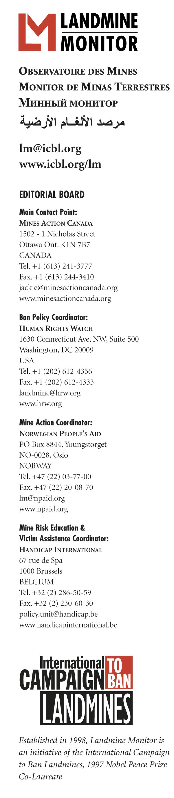
EMBARGOED UNTIL 08:00 GMT, MONDAY 12 NOVEMBER 2007

TOO MANY STATES NOT ON COURSE TO MEET MINE CLEARANCE DEADLINES according to Landmine Monitor Report 2007 released today

GENEVA, Switzerland – 12 November 2007 – Many states are not on course to meet their Mine Ban Treaty mine clearance obligations, according to Landmine Monitor Report 2007: Toward a Mine-Free World. The International Campaign to Ban Landmines (ICBL) releases the 1,124-page report at the United Nations today.

Landmine Monitor reports on the global landmine situation and scrutinizes the implementation of and compliance with the 1997 Mine Ban Treaty. Landmine Monitor Report 2007 is the ninth annual edition of the report.

Time is running short for 29 countries with treaty-mandated clearance deadlines in 2009 or 2010. Despite a treaty provision allowing 10 years to complete mine clearance, 14 states are almost certain not meet their 2009 deadlines: Bosnia and Herzegovina, Cambodia, Chad, Croatia, Mozambique, Niger, Peru, Senegal, Tajikistan, Thailand, the United Kingdom (for clearance of the Falkland Islands/Malvinas), Venezuela, Yemen, and Zimbabwe.

Even more seriously, despite having almost eight years to initiate clearance, France, Niger, the United Kingdom and Venezuela have failed to even begin clearance operations.

“Some countries that should have met their clearance deadlines will probably not be able to do so,” said Mr. Stuart Casey-Maslen of Norwegian People’s Aid, Landmine Monitor’s Mine Action Editor. “Both donors and mine-affected countries must work harder to ensure that countries live up to their obligations under international law.”

Demining programs in 2006 cleared 140 km² of mined areas and 310 km² of battle areas. A significant increase in battle area clearance was recorded over 2005, primarily in Iraq. Afghanistan and Cambodia alone accounted for over 55% of all mined area clearance in 2006. Operations resulted in the destruction of 217,000 antipersonnel mines, 18,000 antivehicle mines and 2.15 million explosive remnants of war (ERW).

Government use of antipersonnel mines declined further, with only Myanmar/Burma and Russia continuing to lay new mines. Non-state armed groups in at least eight countries used antipersonnel mines or improvised explosive devices, which is also a decrease.

A total of 5,751 mine and ERW casualties were reported in 2006, a decrease of 16% from 2005, although Pakistan, Myanmar/Burma, and Somalia recorded increased casualty rates due to conflict. Lebanon noted an approximately tenfold casualty increase. Three-quarters of recorded casualties were civilians, and 34% of civilian casualties were children. Worldwide, 473,000 survivors were identified as of August 2007.

Only 11 of 24 states with significant numbers of survivors have made substantial progress towards their 2005-2009 objectives for improving the provision of assistance and ensuring survivors’ rights. Funding for survivor assistance comprises only 1% of total mine action funding. Progress toward meeting the needs and rights of survivors should be regarded as insufficient.

“Mine-affected countries and international donors must give greater priority to the physical and economic rehabilitation of survivors, as their needs are not being adequately addressed,” said Katleen Maes of Handicap International, Landmine Monitor’s Victim Assistance Editor. “These people must not be forgotten.”

Mine risk education reached approximately 7.3 million people in 63 countries in 2006-2007. Although this is an increase from 2005-2006, 13 countries urgently need to improve their mine risk education efforts. No mine risk education was recorded in 36 countries and one area affected by mines or ERW.

Of the 20 largest mine action donors, 15 provided more funding in 2006 than 2005. Funding for mine action was US$475 million in 2006, an increase of some $100 million from 2005, and the highest level ever recorded by Landmine Monitor. Much of the increase was due to emergency funding for the clearance of explosive remnants of war in South Lebanon.

“While donor states responded quickly to ERW contamination in Lebanon, what is needed is multi-year funding by national and international donors,” said Mr. Anthony Forrest of Mines Action Canada, Landmine Monitor’s Mine Action Funding Editor. “Funding levels in 2006 have set a new standard for the global commitment to mine action, against which future funding levels will be judged."

Antipersonnel mines face increased international rejection, as four more countries joined the treaty (Indonesia, Iraq, Kuwait and Montenegro), bringing the total to 155. “Ten years after the negotiation and signing of the Mine Ban Treaty, the stigmatization of antipersonnel mines continues to spread. Even those who have not yet joined the treaty are largely abiding by its core obligations,” said Steve Goose of Human Rights Watch, Landmine Monitor’s Ban Policy Editor. Seven more countries completed destruction of their stockpiles of antipersonnel mines; in total, 81 States Parties have destroyed nearly 42 million stockpiled mines.

“While overall compliance with the treaty has been impressive, there have been some disconcerting developments,” said Goose. These include a UN monitoring group reporting shipments of antipersonnel mines to Somali factions by two States Parties (Eritrea and Ethiopia, which strongly deny the accusations), two states missing their stockpile destruction deadlines (Afghanistan and Cape Verde, both of which have now completed the task), and Venezuela indicating that it continues to derive military benefit from mines laid around military bases—a potential treaty violation of the prohibition on use.

The treaty prohibits the use, production, and trade of antipersonnel landmines. It requires clearance of mined areas within 10 years and the destruction of stockpiled antipersonnel mines within four years. Landmine Monitor Report 2007 reports on landmine use, production, trade, stockpiling, demining, casualties, survivor assistance and mine action funding in 118 countries and areas.

Landmine Monitor is coordinated by an Editorial Board drawn from four organizations: Mines Action Canada, Handicap International, Human Rights Watch and Norwegian People’s Aid. It constitutes a sustainable and systematic way for NGOs to monitor and report on the implementation of a disarmament treaty.

Landmine Monitor Report 2007 and related documents are available at 08:00 GMT at www.icbl.org/lm/2007 on 12 November.

For more information or to schedule an interview contact:
- Ms. Jackie Hansen, Landmine Monitor Project Manager, Geneva (GMT+1), Mobile +41-76-222-6968 or +1-613-851-5436, email lm@icbl.org
- Ms. Simona Beltrami, ICBL Advocacy Director, Geneva (GMT+1), Mobile +39-33-3714-2251, email simona@icbl.org

