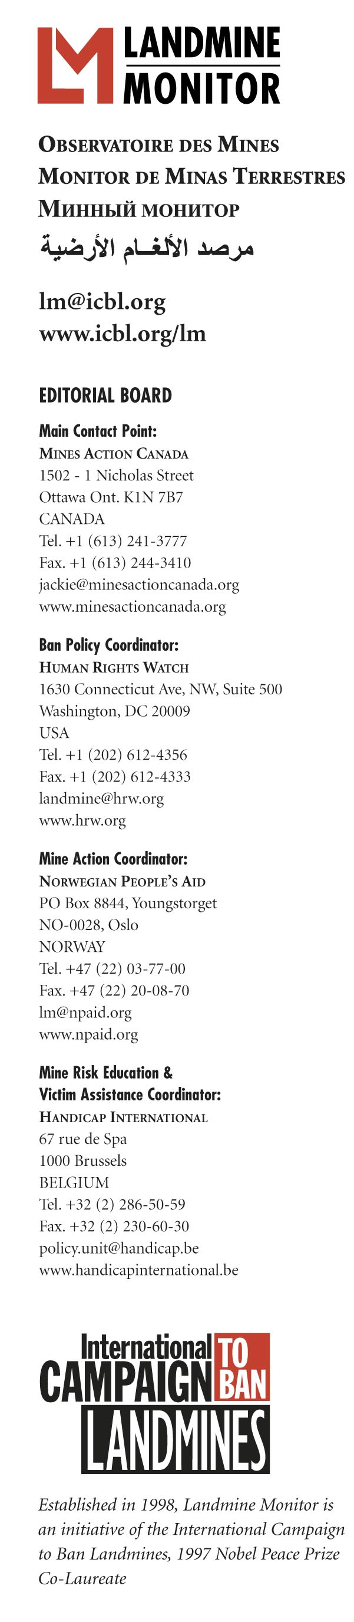
EMBARGOED UNTIL 08:00 GMT, MONDAY 12 NOVEMBER 2007

GLOBAL PROGRESS IN MINE CLEARANCE “TOO SLOW” according to Landmine Monitor Report 2007 released today
BELGRADE, Serbia – 12 November 2007 – Mine clearance in many countries is lagging behind international commitments, Landmine Monitor warns in a global report issued today by the International Campaign to Ban Landmines.
The Mine Ban Treaty gives States Parties ten years after joining to clear all mined areas. Some 50 states, a third of all the treaty’s members, have significant numbers of landmines on their territory. But so far, mine clearance operations have been completed in only five countries with relatively small mine problems: Costa Rica, Guatemala, Honduras, the former Yugoslav Republic of Macedonia, and Suriname.
Worst of all, four nations – France, Niger, the United Kingdom and Venezuela – have failed even to start formal clearance operations, a clear failure to respect the spirit and letter of the treaty. Venezuela has publicly acknowledged that it is keeping existing minefields to use them against Colombian guerrillas, which represents a potential violation of the treaty’s prohibition on use.
Among other countries with 2009 deadlines for mine clearance under the treaty, only Albania and Swaziland look certain to meet their obligations in time. But with increased efforts several other countries, including Denmark, Ecuador, Jordan, Malawi, Nicaragua, and Uganda, could still meet their deadlines. Djibouti is waiting for France to clear an ammunition storage area on its territory before declaring successful completion.
Those states almost certain to fail to meet their 2009 deadlines are: Bosnia and Herzegovina, Cambodia, Chad, Croatia, Mozambique, Niger, Senegal, Tajikistan, Thailand, the United Kingdom (for clearance of the Falkland Islands/Malvinas), Venezuela, Yemen, and Zimbabwe.
The Mine Ban Treaty allows mine-affected States Parties to request an extension period of up to ten years from the other States Parties but these were intended for very heavily contaminated countries and other exceptional circumstances. In 2004, all the member nations of the treaty pledged to ensure that “few, if any” would deem it necessary to request such an extension.
Affected nations need to show greater commitment – both financial and political – in supporting their clearance operations. They need to release land back to civilian use more quickly, particularly by training and deploying survey teams to suspected areas to verify reports of contamination. Too much suspect land is being cleared at great expense only to find that it did not actually contain any explosive hazard at all. Donors need to maintain their support for effective mine action programs.
In the words of Jackie Chan, the international film director and actor, who issued a message of support for the launch of Landmine Monitor Report 2007, “clearance programs need to speed up. Funding must be maintained. I call on all of you – governments, and citizens alike – not to give up until this honorable struggle is won.”
For more information or to schedule an interview contact:
- Mr. Stuart Casey-Maslen, Landmine Monitor Mine Action Coordinator, Belgrade (GMT+1), Mobile +33-686-28-14-15, email stuart@icbl.org
- Ms. Suzana Srnic Vukovic, Landmine Monitor Balkans Researcher, Belgrade (GMT+1), Mobile +381-62-1878-087/ +387-65-578 -444, email srnicvukovic@yahoo.co.uk

