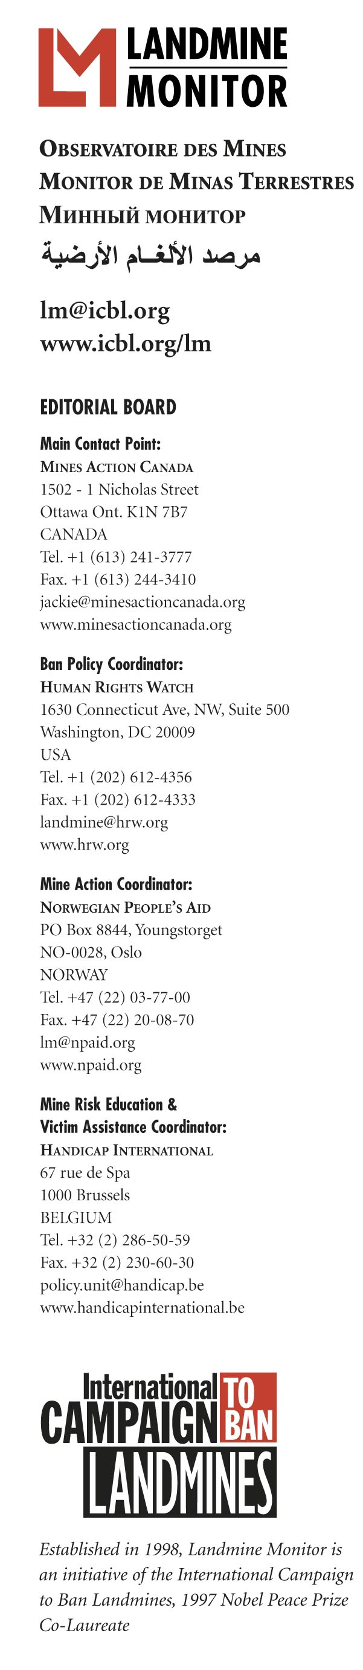
EMBARGOED UNTIL 08:00 GMT (13:00 local time), WEDNESDAY 13 SEPTEMBER 2006

DEMINING IN 2005 A RECORD, BUT MAJOR CHALLENGES REMAIN
according to Landmine Monitor Report 2006, released today

BANGKOK, Thailand - 13 September 2006 - Mine action programs demined more than 740 square kilometers of land in 2005 – more than in any other year since the start of modern demining in the late 1980s, according to the 1,230-page annual report launched today by the Landmine Monitor, the monitoring arm of the International Campaign to Ban Landmines (ICBL). Four programs, Cambodia, Afghanistan, Bosnia and Herzegovina, and Yemen, each released more than 100 square kilometers of land back into use during the year.

The 740 square kilometers demined included clearance of 145 square kilometers of mined areas and 190 square kilometers of battlefields. More than 470,000 landmines, including around 450,000 antipersonnel mines, and more than 3.75 million other explosive devices were removed and destroyed in these clearance operations.

But 78 countries and eight territories are still affected by mines and explosive remnants of war (ERW) that continue to take a heavy human toll, impose huge financial costs and pose a major obstacle to economic and social revival of countries emerging from conflict. In 2005, the number of reported casualties – probably less than half of the real number – totaled 7,328, an increase of 11 percent on 2004. The increase was largely due to intensified conflict in countries including India, Myanmar, Nepal, and Pakistan, with Colombia having the highest number of recorded casualties – 1,110. Up to 500,000 people alive today have survived a mine explosion, many as amputees.

The costs of demining alone run to over $300 million per year and many mine and ERW survivors will need life-long treatment and care. As a result of the Mine Ban Treaty, new use of antipersonnel mines continued to decline. But of the three governments who used antipersonnel mines in 2005 and 2006 – Burma/ Myanmar, Nepal and Russia – two were in Asia. There was also extensive use of landmines and victim-activated devices by non-state armed groups from the region – in India, Nepal, Pakistan, the Philippines, and Sri Lanka. Sadly, Asia was also prominent in the manufacture of antipersonnel mines – accounting for nine of the 13 countries still producing.

The historic demining achievement in 2005 was due largely to efforts in some major mine-affected countries in “area reduction” – the identification of land suspected to be contaminated that does not in fact contain either landmines or explosive remnants of war, without resorting to time-consuming and expensive clearance operations. According to Stuart Maslen of Norwegian People’s Aid, Landmine Monitor’s Mine Action Editor, “For heavily contaminated countries, area reduction is an essential tool in efforts to return land to the civilian population as soon as possible.” Area reduction in all programs for which figures were available accounted for 55 percent of the total area demined worldwide in 2005.

Although annual funding for programs dropped by almost six percent in 2005 compared to the previous year, the total of US$376 million was still the second highest annual figure ever recorded. The biggest contributors to global mine action in 2005 were the United States ($81.9 million), the European Commission ($51.5 million), Japan ($39.3 million), Norway ($36.5 million), the United Kingdom ($21.4 million), Germany ($21.1 million), Canada ($20.5 million) and the Netherlands ($19.3 million).

In the words of the ICBL Executive Director, Sylvie Brigot: “The prospects for maintaining the present rate of progress in freeing countries from the scourge of mines and fulfilling their treaty obligations will depend on donors maintaining or increasing their level of financial support. But competition for donor funding is growing and mine-affected countries will need increasingly to demonstrate their own commitment to mine action by committing more of their own resources.”

Also in 2005, two mine-affected countries – Guatemala and Suriname – reported completing clearance of all antipersonnel mines from mined areas on their territory. Such clearance is required of all mine-affected States under Article 5 of the Mine Ban Treaty within 10 years of becoming a party. A total of 29 affected States Parties have still to complete clearance between March 2009 and the end of 2010. As of mid-2006, however, only half of these appeared likely to meet their respective deadlines: Albania, Djibouti, France (a French military base in Djibouti), Jordan, the Former Yugoslav Republic of Macedonia, Malawi, Namibia, Nicaragua, the Philippines, Rwanda, Swaziland, Tunisia, Uganda and Venezuela. In addition, Ecuador and Peru have publicly affirmed their determination to meet their respective deadlines, although it is not certain that they will be able to make it in time.

Landmine Monitor also highlights cases where mine-affected States Parties have not acted “as soon as possible” as required by the Mine Ban Treaty to plan and conduct a demining program. These States Parties include Denmark, France, Niger, Swaziland, Venezuela and the United Kingdom.

In other cases, States Parties have initiated demining operations but made slow progress, to the extent that completion of operations before the Article 5 deadline appears to be in doubt, or in some cases is questioned by officials. Thailand’s Foreign Minister warned the Prime Minister in March 2006 that the progress of demining was slow and as a result, Thailand would not meet its Article 5 deadline of 1 May 2009. Reasons given for the slow progress included that mine action had not been a government priority, inadequate financial support, and the military structure of mine action in Thailand.

The treaty does allow States to request an extension from the other parties. In 2004, at the first Review Conference of the treaty, all States Parties agreed that they would strive to ensure that “few, if any” would be required to request such an extension. Landmine Monitor believes that more than a dozen States are not on track to meet their deadline: Bosnia and Herzegovina, Cambodia, Chad, Croatia, Denmark, Mozambique, Niger, Senegal, Tajikistan, Thailand, the United Kingdom (Falkland Islands), Yemen and Zimbabwe.

The International Campaign to Ban Landmines (ICBL) considers the Mine Ban Treaty the only viable comprehensive framework for achieving a mine-free world. Signed by 122 governments in Ottawa, Canada in December 1997, the Mine Ban Treaty had 151 States Parties as of 1 September 2006. An additional three states have signed but not yet ratified. A total of 40 states, including major military powers China, India, Pakistan, Russia and the USA, remain outside the treaty.

For more information or to schedule an interview contact: Ms. Karolina GUAY, Landmine Monitor, Bangkok (GMT+7), Mobile 07-806-7178 or +33-686-28-14-15, email: karolina@icbl.org.

